Optimizing Mask Fit and Filtration

INTENDED AUDIENCE: All caregivers

What is the change?

The CDC has recently released studies that emphasize the importance of ensuring proper fit, and in turn filtration, of masks to prevent transmission and exposure to Covid-19. In lab tests exposure to potentially infectious aerosols decrease by about 95% with a tightly fitting mask.¹

Important information for clinicians:

Recommended actions to improve mask fit and filtration:

- Knotting and Tucking: Knot the ear loops of a 3-ply face mask where they join the edge of the mask, then fold and tuck the unneeded material under the edges.

- Nose Wires: Use masks that have a nose wire (a metal strip along the top of the mask) to help prevent air leakage at the top of the mask. To get a good fit, make sure to bend the nose wire over your nose to conform to your face. Nose wires can also help to prevent fogging of eyeglasses.

A. |  |  | B.
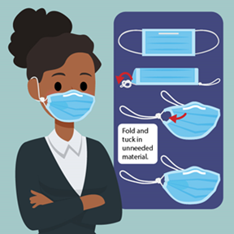

Additional references and resource links:
- Maximizing Fit for Cloth and Medical Procedure Masks to Improve Performance and Reduce SARS-CoV-2 Transmission and Exposure, 2021 | MMWR (cdc.gov)

DISTRIBUTION / COMMUNICATION PATHWAY: Nursing Education and Adoption Team (NEAT) and Nursing communication distribution pathways.

